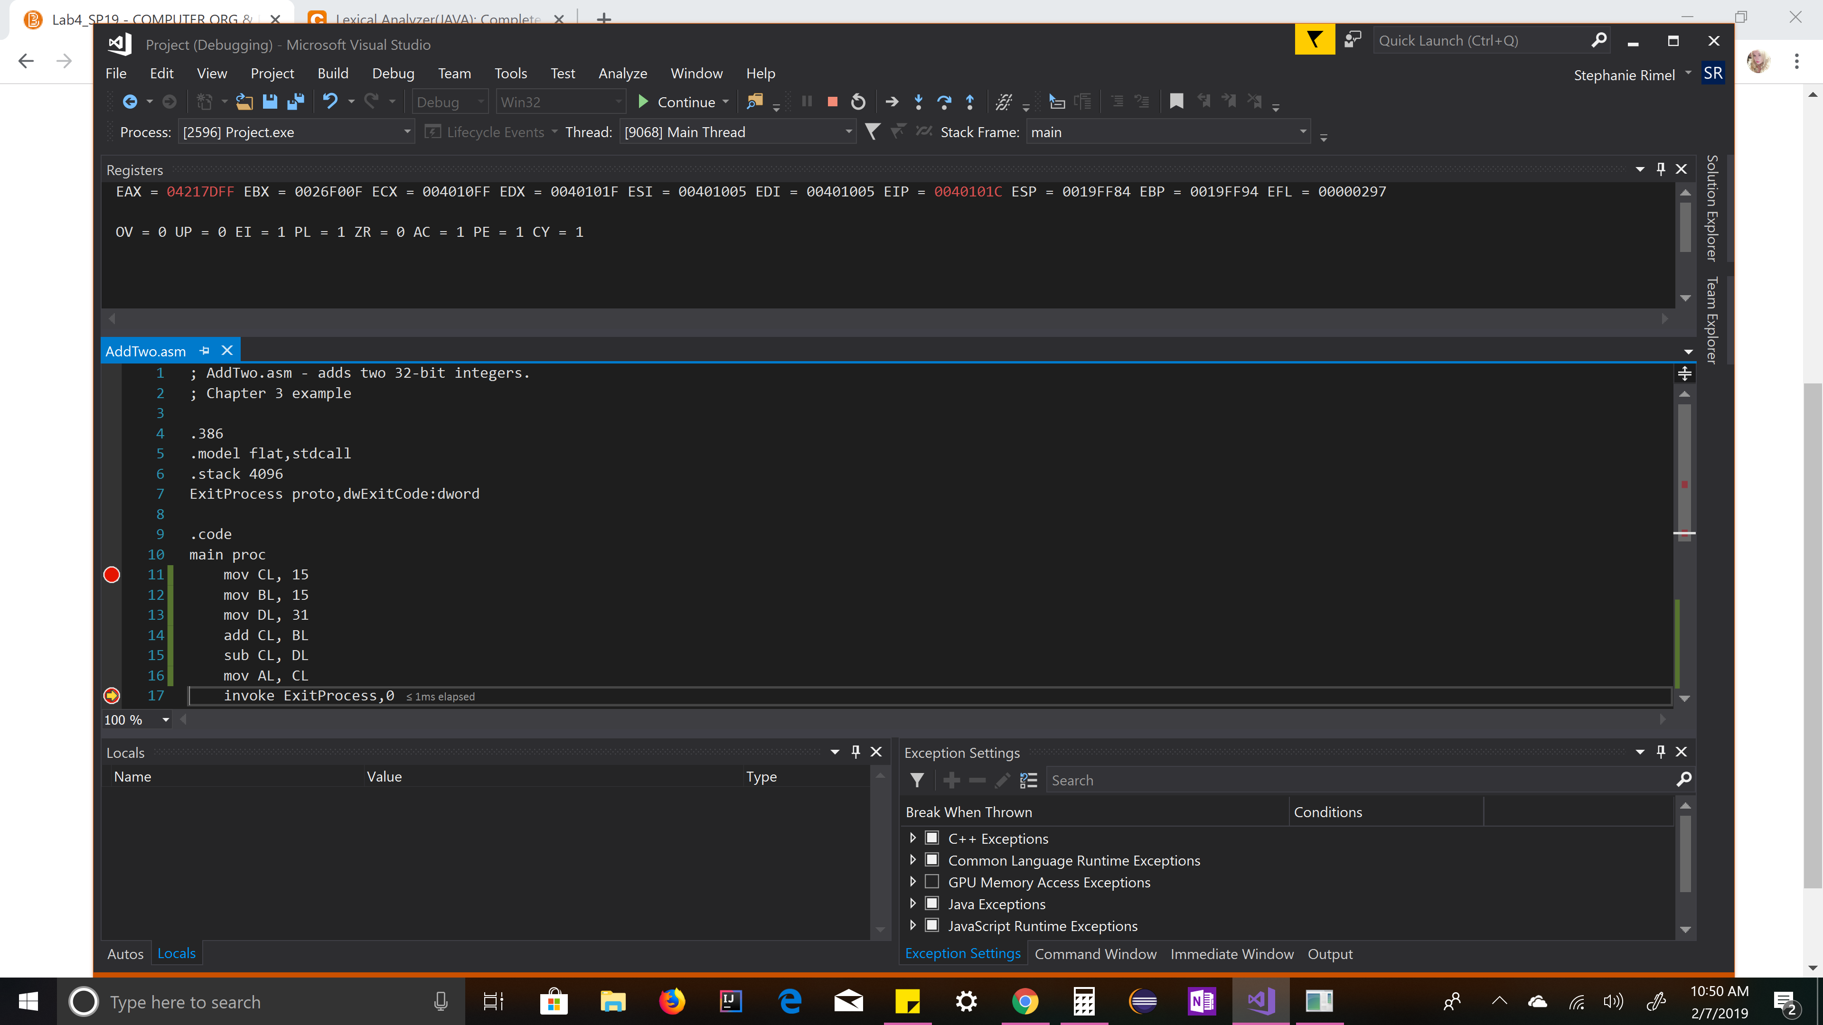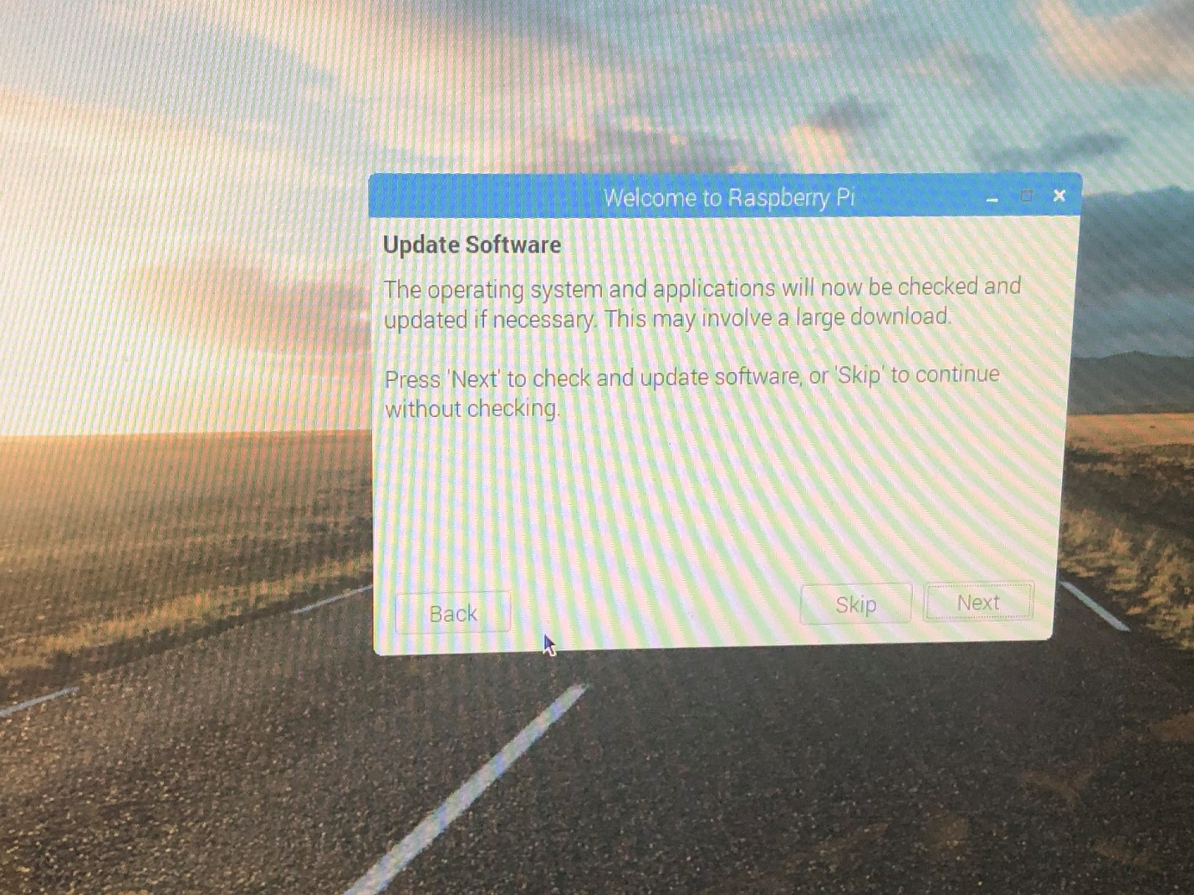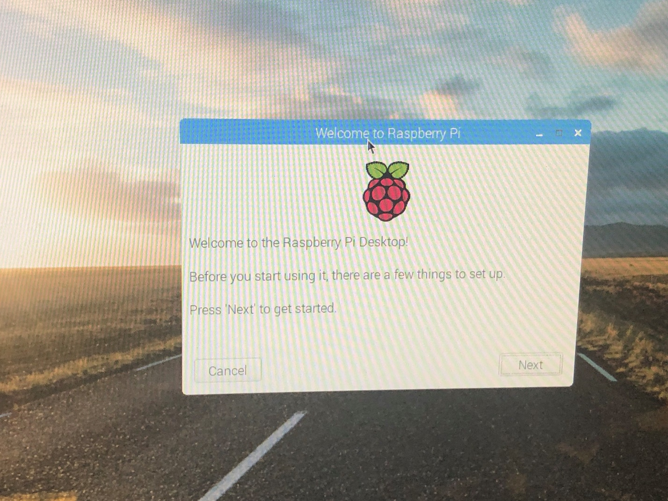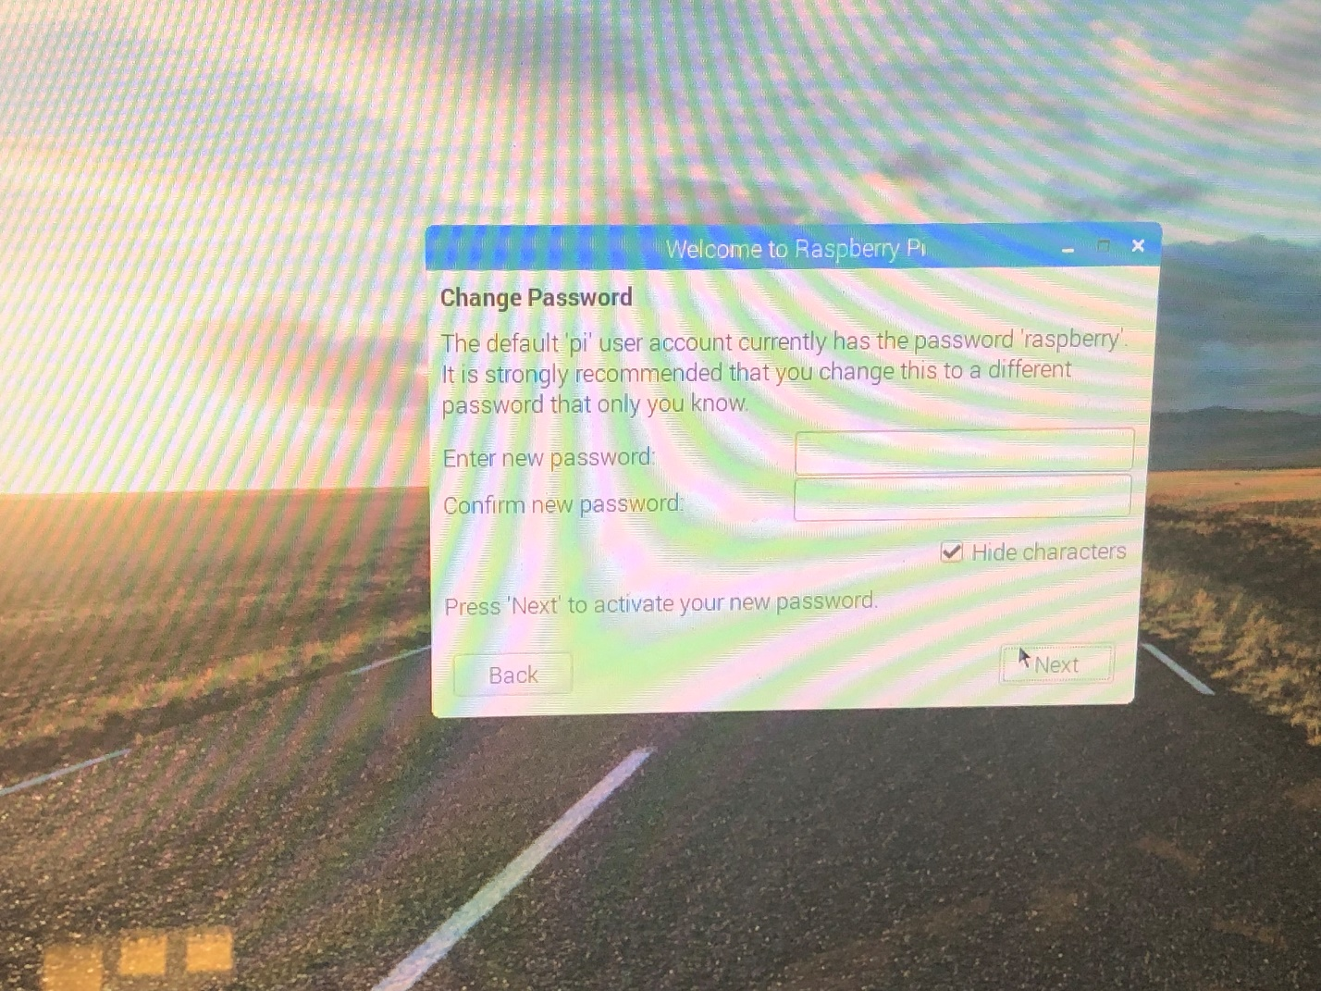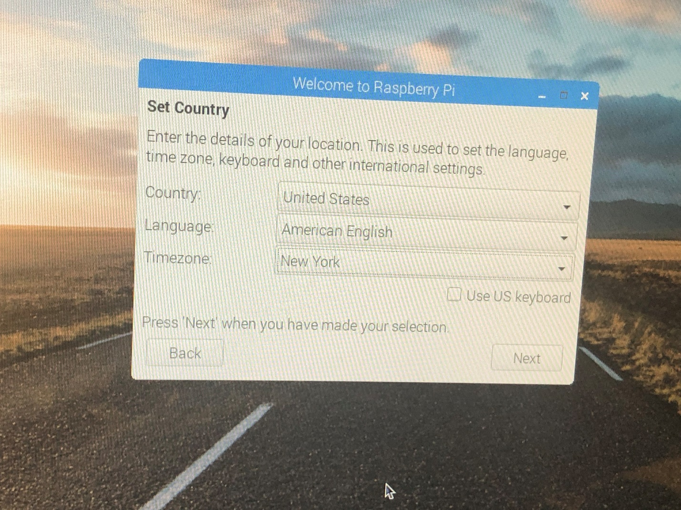C:\Users\snowe\Downloads\SS1 (1)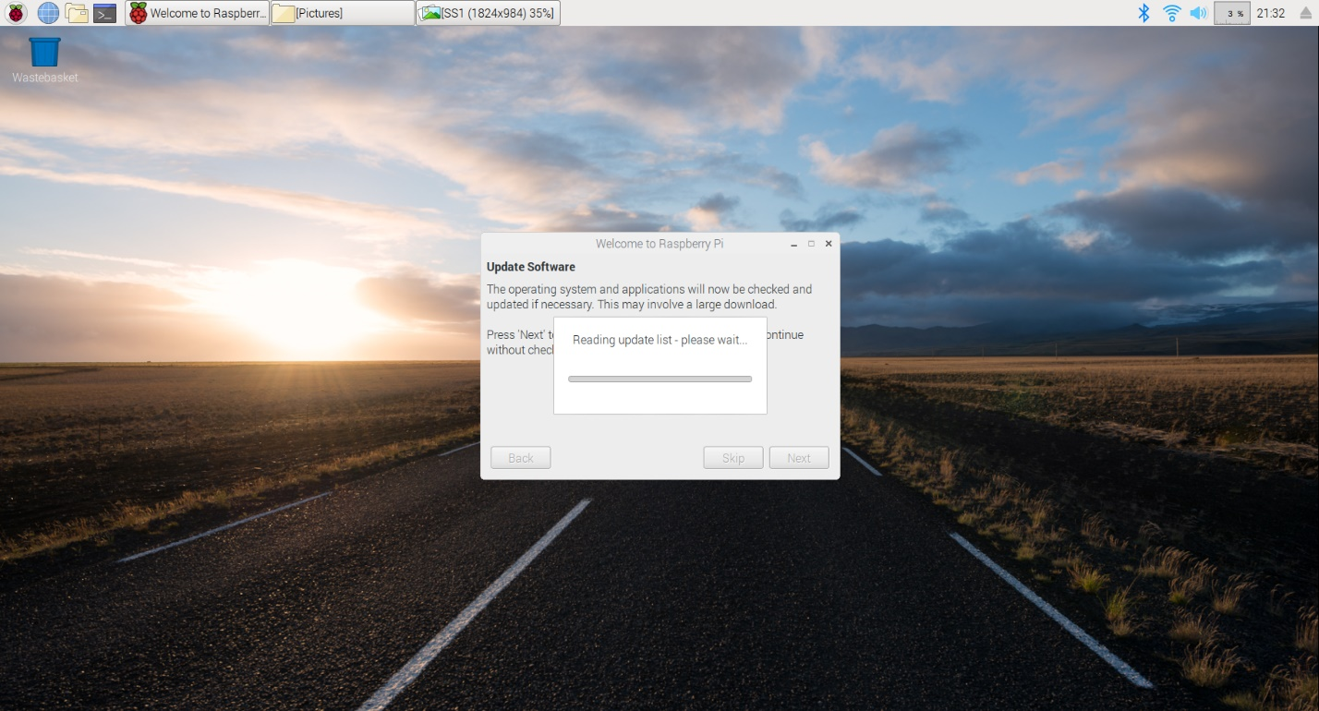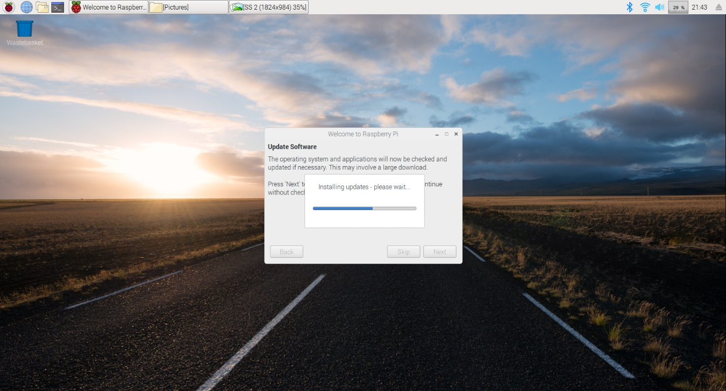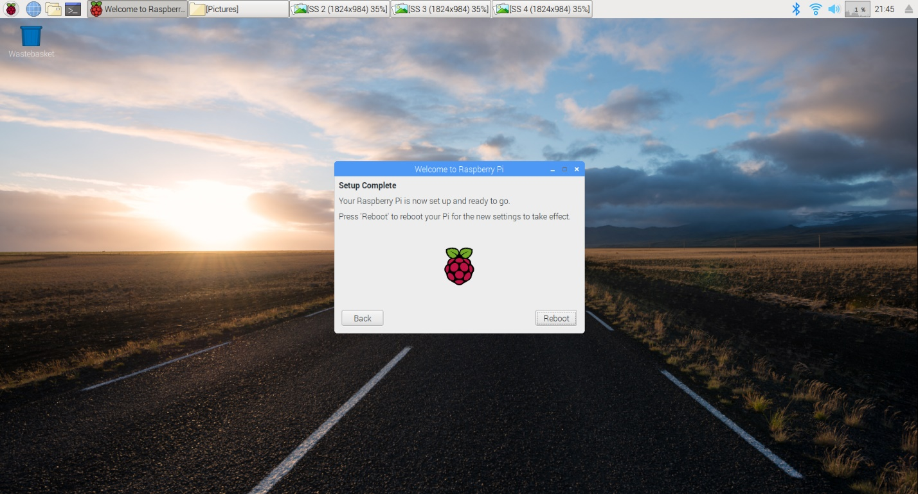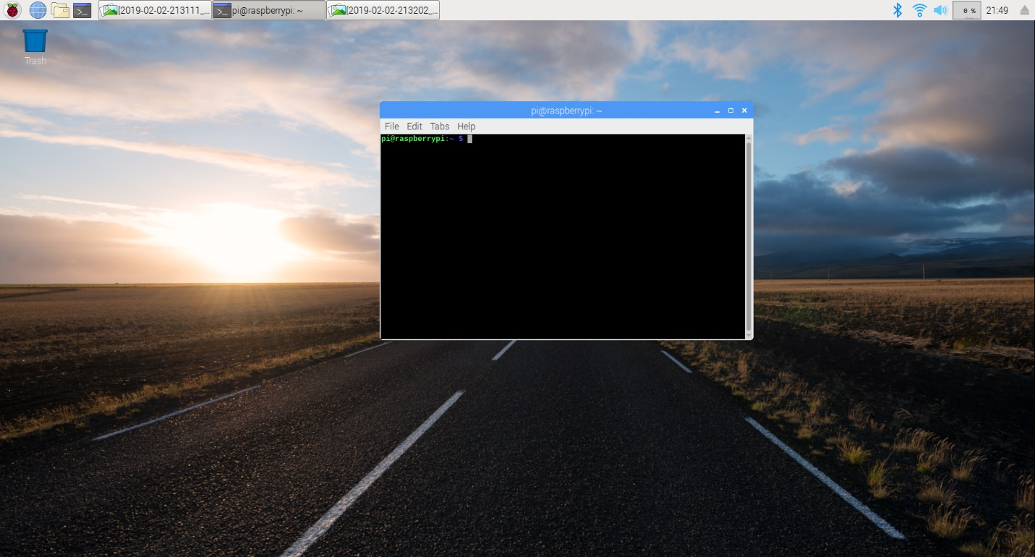C:\Users\snowe\Downloads\SS 7.gif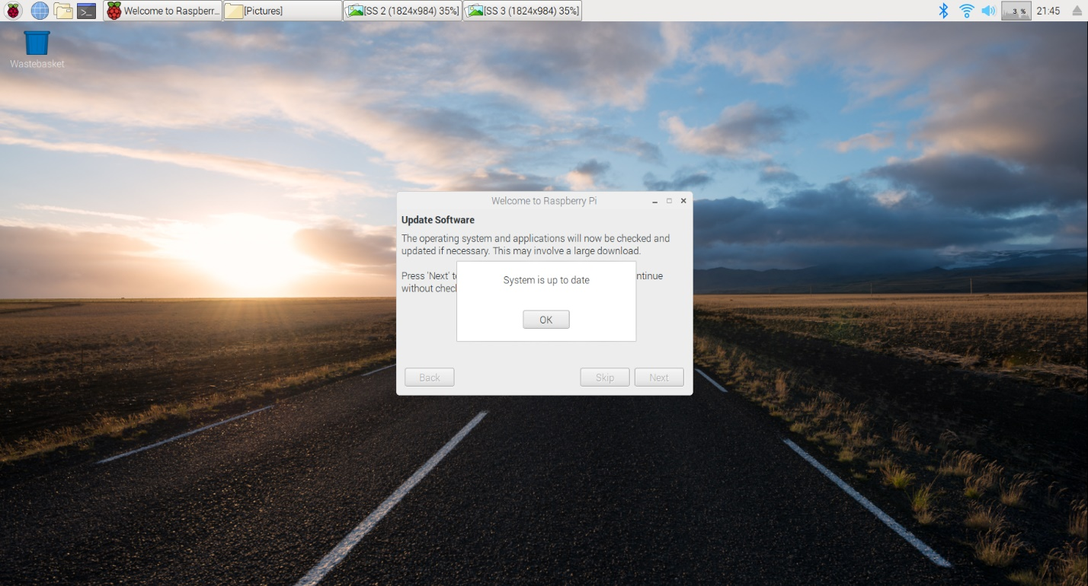C:\Users\snowe\Downloads\SS 8.gifC:\Users\snowe\Downloads\SS 9.gifC:\Users\snowe\Downloads\SS 10C:\Users\snowe\Downloads\SS 11.gifC:\Users\snowe\Downloads\SS 12.gifC:\Users\snowe\Downloads\SS 13C:\Users\snowe\Downloads\SS 14.gifC:\Users\snowe\Downloads\SS 15.gif